PCL Library in Eclipse Tutorial
author- Karol Hausman

- Please install the pcl – library as it is said in the tutorial: http://pointclouds.org/downloads/source.html

- Build your own project and link it against pcl. In order to do so, please follow this tutorial:
http://pointclouds.org/documentation/tutorials/using_pcl_pcl_config.php#using-pcl-pcl-config

- Now open eclipse and build a new project using the option File → New → Makefile project with existing code.

Give the path to your just made project where the existing code is.

In the list of Toolchain for Indexer Settings please pick Linux GCC option.

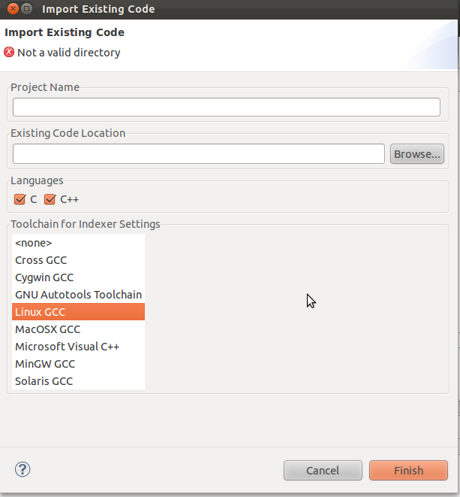

- Your project is already made, now we have to configure it properly. In order to do so please go to the properties of the project (right click on the project in list of projects → Properties )

Open the list called C/C++ General and go to Paths and Symbols tab. Then in the Includes tab pick GNU C++ and add the directory where all of pcl includes are. By default it should be
(for 1.5 pcl): /usr/local/include/pcl-1.5

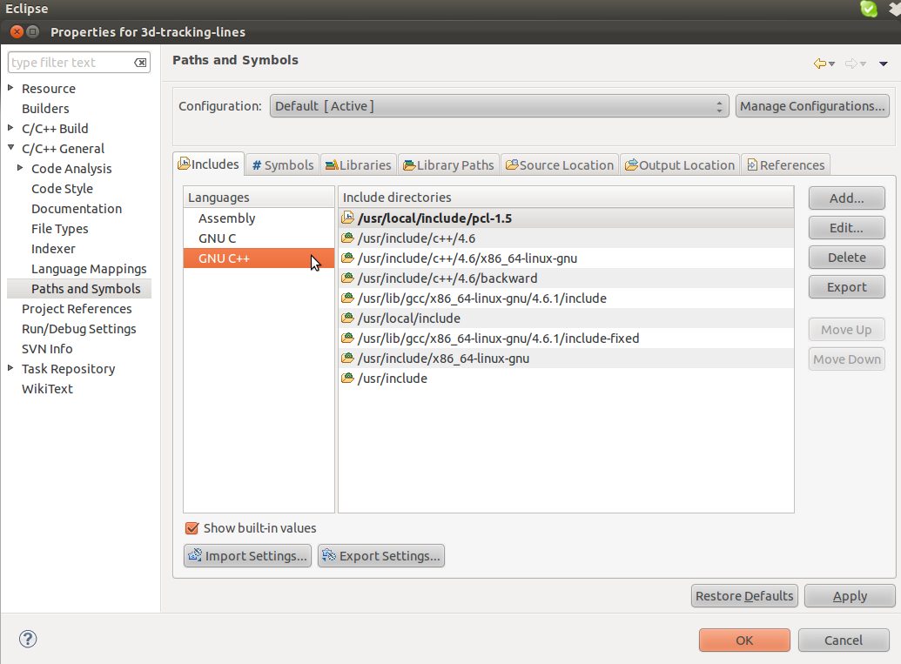

Then please go to Libraries tab and add the directory where all of pcl lib files are. By default it should be: /usr/local/lib

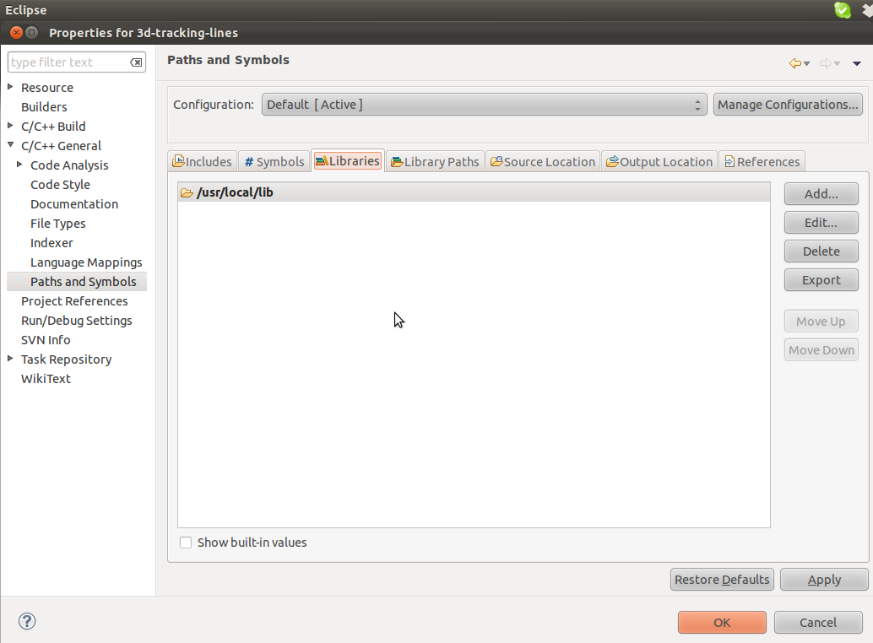

We are still in the Properties of the project window. Please go to C/C++ Build in the list on the left side and open Builder Settings tab. In the Build Directory field please type in the directory where Makefile of your project is. If you did the previous pcl tutorials it should be : your_project_path/build

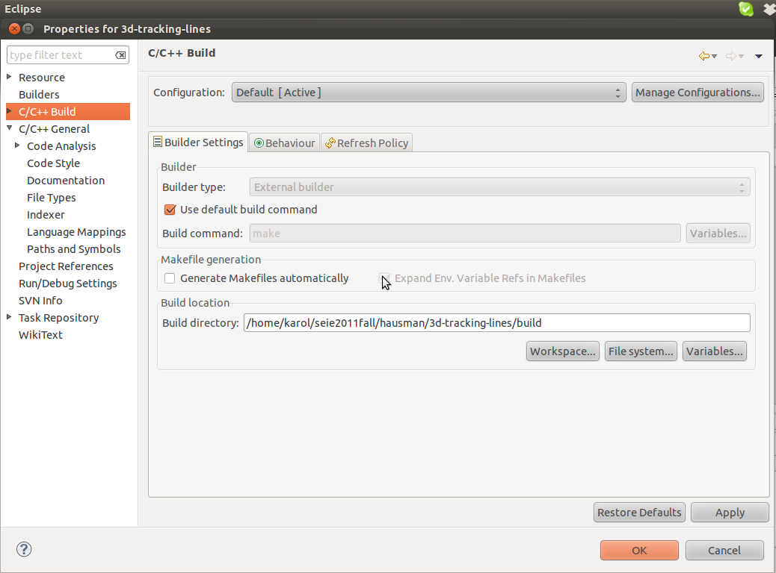

- In terms of configuration that is it. Just try if your project can be build in eclipse by clicking Ctrl +B

- If you have problems with running your project, go to the Run → Run Configuration and check if all of the parameters in Arguments tab are ok.

- You may notice that in your c++ file in eclipse there are still some errors mainly connected to typedef statements. Do not worry about that, just continue launching the program. I am currently working on how to add typedefs too :)

